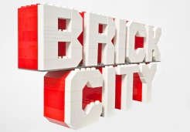 Competition - Application Form

Applicant full name/ names:
Applicant address:
Contact telephone number:
Age of maker/ makers
Please say a little about your model (50 words max)

Models should be delivered to 20-21 Visual Arts Centre, Church Square Scunthorpe between Tuesday 13 June and Saturday 17 June 10am to 4pm.

Terms and Conditions:
- Judging will be on Wednesday 21 June and entrants will be informed of the results on that day.
- Models must be collected from 20-21 from Thursday 22 and Saturday 24 June 2017.
- All entries must be accompanied by a complete application form.
- Models must be made entirely from the applicants own LEGO® - please do not use bricks form our activity area or from the Brick City exhibition!
- There is no minimum or maximum size for entries (however you will have transport your model to and from the gallery!).
- Joint entries are accepted.
- Any age may apply. Please note: the Creator Tower Bridge set is recommended for ages 16+ however alternative sets may be selected if not age-appropriate for the winner.
- Employees of 20-21 Visual Arts Centre or Warren Elsmore Ltd are not eligible to apply.

Brick City at 20-21 is sponsored by The Clugston Group.

